RDC Reconciliation

Internal Accounts
PL52024 Remote Deposit Capture SC
CAD1011500011001 Remote Deposit Capture
USD1011500011001 Remote Deposit Capture

Transaction Codes
Corporate RDC the FTTC is ACDD (77 credit/ 76 debit)
Mobile RDC the FTTC is ACDM (45 credit/ 962 debit)

Files
Computer Ops will create a daily folder in N:\MISCommon\CAP\RDC\YYYY\MM\DD and copy all the C1 files to the folder. The files to be copied are:
- T24 Posting file(s):
  - Corporate CAD: CWB-CRDC-CAD-YYYYMMDD.txt
    - If empty: CWB-CRDC-CAD-YYYYMMDD-EMPTY.TXT
  - Corporate USD: CWB-CRDC-USD-YYYYMMDD.txt
    - If Empty: CWB-CRDC-USD-YYYYMMDD-EMPTY.TXT
  - Mobile CAD: CWB-MRDC-CAD-YYYYMMDD.txt
    - If Empty: CWB-MRDC-CAD-YYYYMMMDD-EMPTY.TXT
- XML File(s):
  - Corporate CAD: RDCCMMDD.DAT
  - Corporate USD: RDUCMMDD.DAT
  - Mobile CAD: RDCMMMDD.DAT

- MERG File(s) – S/B Daily Deposit Extract file(NEW)
  - MERGMMDD.DAT
The T24 posting error log will be copied so N:\MISCommon\CAP\RDC\Posting Error Logs\YYYY\MM, where:
- YYYY is the year, and
- MM is the numeric representation of the month
e.g. N:\MISCommon\CAP\RDC\Posting Error Logs\2017\07
Note: The following key is used for the filenames outlined above:
- YYYY – 4 digit year e.g. 2017
- MM – numerical 2 digit number to represent month e.g. 07 for July
- DD – zero-filled, 2 digit calendar day e.g. 17 or 07 (for 7th)

Daily Deposit Extract file(s)
Computer Ops will create a daily folder in N:\MISCommon\CAP\RDC\YYYY\MM\DD and copy all the C1 files to the folder.
The Daily Deposit Extract name will be name CWB-CRDC-CUR-DET- YYYYMMDD.CSV
!Note: The CUR will be the currency of the file, set to either CAD or USD
!Note: YYYMMDD is the year + month+ day of the month in which the file was generated. This naming convention should match the T24 Posting file formats (XML-FUNC005 of RDC BRD)
The Daily Deposit Extract will still be generated even if no records were submitted. The empty files will be tagged with “-EMPTY” in the filename
At the same frequency as the T24 posting files, we will receive detailed itemized batch details in one of 3 Daily Deposit Extract files. The daily details will be in these 3 files:
- CAD
  - CWB-CRDC-CAD-DET-YYYYMMDD.csv
  - CWB-CRDC-CAD-DET-YYYYMMDD-EMPTY.csv, for empty files*
  - CWB-MRDC-CAD-DET-YYYYMMDD.csv
  - CWB-MRDC-CAD-DET-YYYYMMDD-EMPTY.csv, for empty files**

- USD
  - CWB-CRDC-USD-DET-YYYYMMDD.csv
  - CWB-CRDC-USD-DET-YYYYMMDD-EMPTY.csv, for empty files*
*These files have no records to process
** The mobile files will not be available until the mobile RDC project is completed.
The data in the files will contain:
Field | Description | Format | Default | Sample
Currency | The currency in which the customer selected to deposit funds into.  Values can only be "CAD" for Canadian, or "USD" for US | Must be CAD or USD | N/A | CAD
Deposit Date | The date in which the deposit was accepted from the customer. | YYYYMMDD  YYYY = Year  MM = Digital representation for month  DD = Day | N/A | 20170921
Deposit Type | Flag to determine whether the capture was done via Corporate Capture or Mobile.  Values can only be "Corporate" | Text  Values can only be "Corporate" | Corporate | Corporate
Unlisted Transit Number | A unique transit number that is assigned by CMS at the time of customer setup. CMS track the usage of the used transits. | Format is 0030-88888  0030 = CWB's Route  99999 = Unique number assigned by CMS (Transit) | N/A | 0030-00001
Location | Unique account-level identifier is used by Central 1. | Text | N/A | 03-003000001-001-CAD-DB
CWB Account Number | The CWB Account number being deposited to.  This number is provided to C1 as "Business Customer Deposit Account Info - Account Number" on the Central 1 "Corporate Capture Implementation Requirements - V3" form. | Numeric, up to 12 digits | N/A | 101007191848
CWB CIF | The CWB Customer Identification Number.  This identification number is provided to C1 as "Business Customer #" on the Central 1 "Corporate Capture Implementation Requirements - V3" form. | Numeric, 6-digits | N/A | 219875
Business Customer Name | The CWB Customer Name | Text |  | ABC Transport Ltd.
CWB Customer Route/ Transit | The home branch of the CWB Customer, this is where rejects will be routed to.  This route/transit number is provided to Central 1 as "CAD Deposit Slip Route/Transit" or "USD Deposit Slip Route/Transit" on the Central 1 "Corporate Capture Implementation Requirements - V3" form. | Format is 0030-99999  0030 = CWB's Route  99999 = CWB Home Branch of the customer | N/A | 0300-03029
Batch Trace ID | The daily unique identification number for the batch.  Note: This is only unique by business day date.  Note: This Trace ID is part of the RDC Transaction Additional Narrative | 8-digit number |  | 29616332
Deposit ID | The unique batch identification number. This number is presented to the customer at the time of scanning.  Note: Deposit ID is part of the RDC Transaction Narrative | 6-digit number |  | 154874
Accepted Date | The date the batch was accepted | YYYYMMDD  YYYY = Year  MM = Digital representation for month  DD = Day |  | 20170921
Item Trace ID | The per-item trace identification number | 8-digit number  Typically in sequence of the batch trace ID |  | 29616432
Item Scan Sequence | The sequence number in which the item was scanned in the batch | Number,  Starts at 1 for each batch |  | 1
Cheque MICR Route/Transit | The Route/Transit number read on the MICR line of the scanned item | Format is 8888-99999  8888 = Route  99999 = Transit Number | Number | 0030-12345
Cheque MICR Account number | The Account number read on the MICR line of the scanned item | text | text | 78-00223
Amount | The amount of the scanned item, the amount to be deposited. | Dollar amount  Format 99999999.99 |  | 1486.52

T24 Transactions (aka POSTED file)
The RDC transactions posted will be value dated the same day as the file was received/scanned by the customer. The transactional information is listed below:
- Transaction Code: 76 (FTTC is ACDD) Credit
- Transaction Code: 77 (FTTC is ACDD) Debit
- Transaction Code: 45 (FTTC is ACDD) Credit
- Transaction Code: 962 (FTTC is ACDM) Debit
- Payment Details will house “Ref ID: ” + Deposit ID (6 digits zero filled from start)
- Trace.No will house Trace ID

T24 Posting Error Log
When records from the DM posting file cannot be loaded to T24, the rejects will be dumped to an error log. See XML FUNC003 for error file information. The Error log will consist of T24 error messages, suffixed with the DM Load data, similar to:
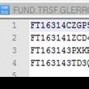
!Note: This sample was taken from a different DM Load error log
Filenames: see XML FUNC011
File Location: see XML FUNC011
File Format: see C1-005

Balancing
To balance cRDC, there are 3 required pieces to balance:
- Credits Received from RBC
- Daily Deposits Central1 Received
- Credits posted in T24 to customer accounts

RBC Credit Validation
To verify the credits received from RBC to what C1 received, open the “RBC Credit Validation” tab.
- Enter in the credits received from RBC under CAD credits. These will show up under RBC account 07172-1013192.

- Allocate the Scanned Credits that were pushed out through Central 1.
  - First, go into the folder to find the daily deposit details found here: N:\MISCommon\CAP\RDC\YYYY\MM\DD
    - The Daily Deposit Extract name will be name CWB-CRDC-CUR-DET- YYYYMMDD.CSV & CWB-MRDC-CUR-DET- YYYYMMDD.CSV
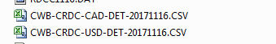
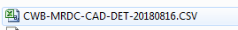
  - Open the CAD files, select all and copy and paste to the CAD Daily Deposits worksheet in range A2.
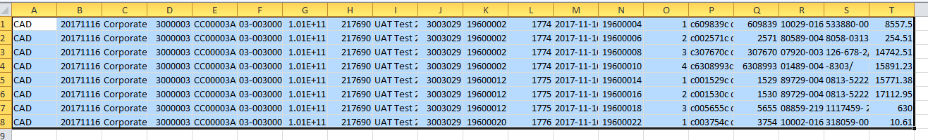
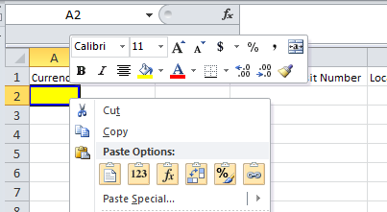
  - Repeat steps for USD file.
- Once both files are input, go back to the RBC Credit Validation worksheet and click refresh. The Differences should now be at zero. See trouble shooting if it does not balance to zero.

Internal Account Reconciliation
- Enter in the closing balance of the internal account for the reconciliation’s date. After adding the credit’s received (this is auto-populated from the RBC Credit validation sheet), the difference should be at zero.
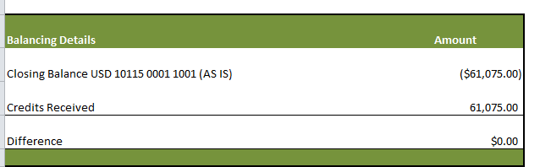

- If it is not at zero, open the RDC Exception report, found on the Report Portal. Enter in the Report Date and Currency and hit “view report”.
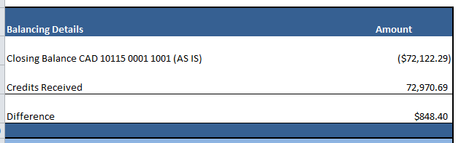
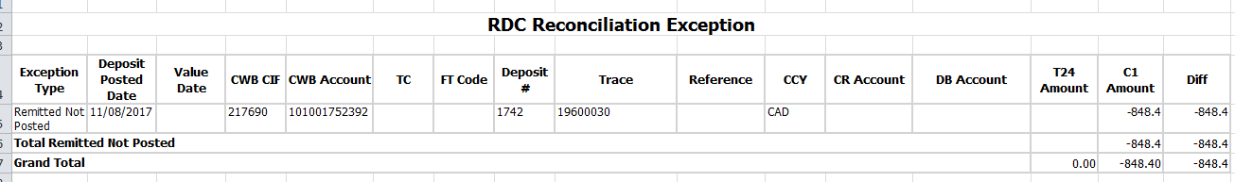
- In this case, there is a “Remitted Not Posted” exception, meaning the deposit was submitted but not posted in T24 (See Exception Report for more details). List the total exceptions and now the difference should be at zero.
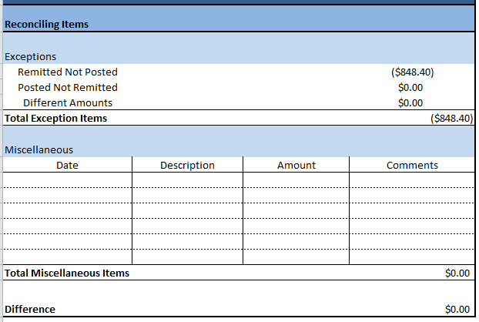
  - When a deposit is not posted, look at the posting error file, located here: N:\MISCommon\CAP\RDC\YYYY\MM\DD
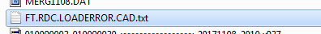
    - Open the file, select all, copy and paste to A2 on the “Posting Error File” Sheet. This will provide you with the Error on why it did not post. In this case, the account number provided is not on T24. Send the details to Cash Management Support and wait to see what should happen, post to different account or re-open account, etc…
  - Once it has been approved to post, the admin would post the following using FUNDS.TRANSFER:
    - FT = ACDD (Corporate), ACDM (Mobile)
    - DEBIT ACCOUNT = CAD1011500011001 OR USD1011500011001
    - CURRENCY = CAD OR USD
    - CREDIT ACCOUNT = CUSTOMER ACCOUNT
    - VALUE DATE = DATE DEPOSITED
    - REMARKS = “Ref ID: ######” where the number = Deposit #
    - TRACE = BATCH TRACE ID
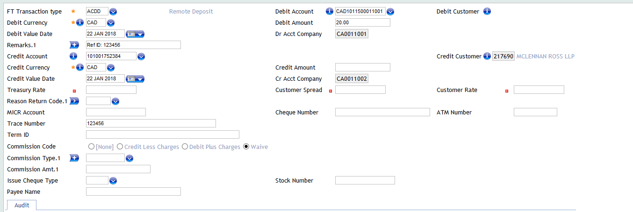

- After both the CAD & USD Internal Accounts have been balanced, complete the postings found on the “Postings” tab. This transfers the funds to the NDDS IA, which in turn, gets transferred to the CAD Bank account.
- Order of hand in:
  - CAD Reconciliation
  - USD Reconciliation
  - RBC Credit Validation
  - Closing Balances of Internal Accounts
  - Credit on RBC Statements
  - Postings
- Save a backup of the daily Excel file re in “G:\Reconciliations\REMOTE DEPOSIT CAPTURE(RDC)\cRDC\Backup”

NDDS Rec Impact
The NDDS Rec will need to exclude the Credits for RDC that come in on the RBC NDDS Accounts (07172-1013192 & 07172-4003968). Instead of posting two different postings to Bank, I propose we transfer the funds from IA 10115 to IA 10112 and, in turn, flow to Bank (IA 10138).

This will have no impact on the Bank Rec team, in which they still just need to match the NDDS postings to the RBC Opening Balance of accounts 07172-1013192 & 07172-4003968. The only change for the NDDS rec would to include the cRDC credits while reconciling.
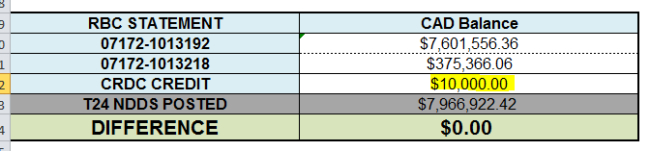
If CAP Edmonton does the RDC rec before the NDDS rec is done and do the postings to 10112, then you will not have to carry anything.
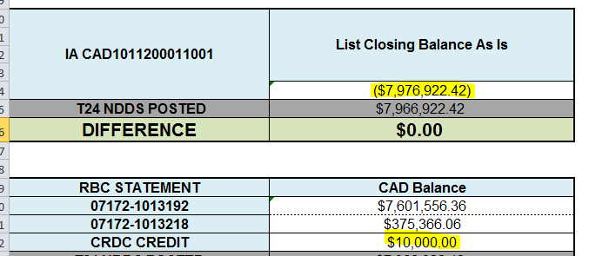
If CAP Edmonton has not, then the RDC Credit Posting will have to be carried on the rec.
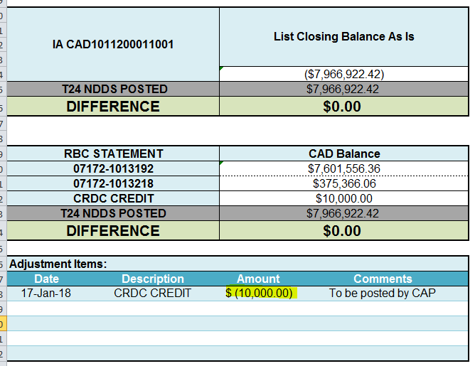

Rejects/Chargebacks
Sometimes Cheques will be rejected, due to MICR mismatch issues. RBC will debit our account and we are to chargeback our client.
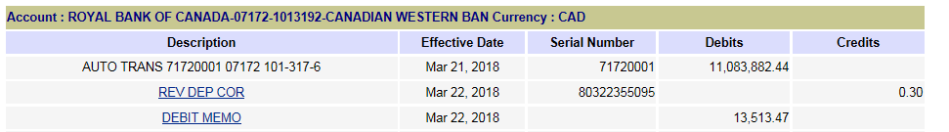
We may not see the debit to our account, until a couple days later, so it is good to have a list of all possible rejects, which is located here: G:\Reconciliations\REMOTE DEPOSIT CAPTURE(RDC)\cRDC\MICR_Mismatch_List.xlsx
Everyday the admin is to copy and paste all possible rejects from the cRDC daily deposit reports. To do this, go under the “Cheque Raw MICR Line” field and filter anything that contains a “!”.
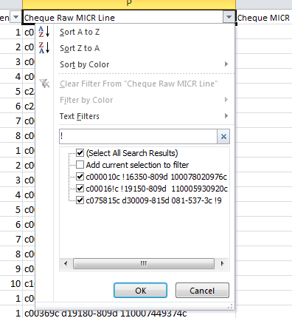
Copy the details and paste at the bottom of the outstanding list.
From the example above, with the 13,513.47, this cheque was deposited on March 20th, 2018, but was not debited till the 22nd. Enter the date it was debited and enter that it has been charged back to the customer, once complete.
To get the image for the chargeback, go into the Central1 Branch Capture site and click Research.

For the criteria, enter in the deposit date and the posted amount, then click search.
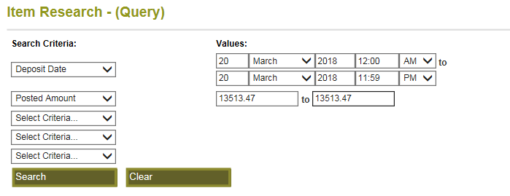
Click the icon under the Tasks field for the Check to view it.
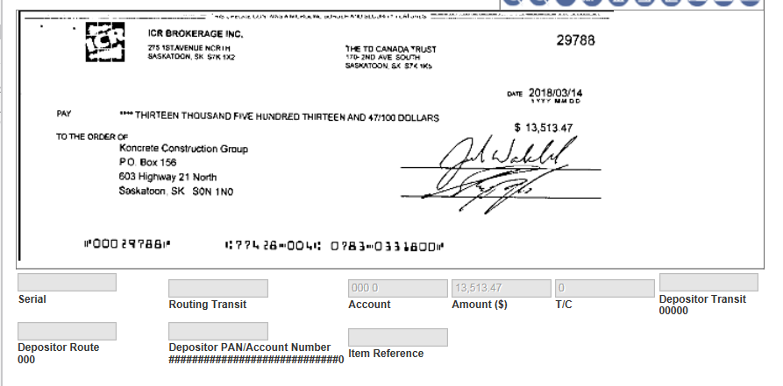
As you can see the MICR fields are blanks, so there was a capturing error. Take screen shots of the front and back to provide to the Admin who is processing the chargeback.

Trouble Shooting

RBC Credit Differences

Missing X9 file:
- Credit not received due to X9 not processed at Central 1 or RBC. Email the following groups with details of the missing credits:
  - Shami.ramsaran@rbc.com
  - Barb.pach@rbc.com
  - Support@central1.com and phone 1 888 889 7878 select option 1
  - Start a ticket with Central 1 via their online service portal – “Is Something Broken”

Eg: “… the CWB Reconciliation team has identified that we did not receive credit for Corporate Remote Deposit Capture file processed for July 23 2018.
It also appears that we did not receive the acknowledgement file either.
The dollar amount of the cheques in the file should be $3,334,496.34 or x2 including the credit voucher $6,668,992.68.”
- Advise Treasury Cash Management of the missing credit and the expected time / date to receive the credit
• If a USD deposit is transmitted with a southbound item(s) in it the X9 file creation will put the item in a temporary X9 file for USD southbound, and that file will be placed in your SFTP directory should you want to view the images. –The deposit of a southbound item will be part of the posting file from Central 1 to CWB. Reporting from C1 and the customer posting file will match but what we posted to the customer account and what RBC credited CWB for will be out.
To Figure out if there was a southbound item, go to the USD Daily Deposits worksheet. If any cheques have are showing in a red color that means that these US cheques “might” be drawn on a US FI. If it was drawn on a US FI, the customer will need to be debited for that cheque and the branch must be notified, so the customer knows that this cannot be done.
If there is an outage between what RBC has credited and what Central 1 has sent out that does not involve a US cheque on a US FI, inform a manager. An investigation will have to be started between C1 and RBC to locate why credit was not received.

Exception Report
The Exception Report shows all exceptions between T24 and what Central 1 submitted. This Report is maintained by BI, if there are any issues with it, create a ticket illustrating the issue. There are 3 main categories:
- Remitted Not Posted
  - Data scanned & submitted by the customer but not posted.
  - These should be found in the posting error log.
- Posted Not Remitted
  - RDC data posted but not submitted by C1. These are RDC Credit transactions that have been posted to T24 without a matching record received from Central 1 RDC system.
- Amount Differences
  - Received and posted, but amounts differ.
If the Exception Report is unavailable, there is a manual balance process on the cRDC Reconciliation.

